**KKPA PC Pekerja**

**Data Pengujian**

| Nama Pekerja | : | Dwinta |
| --- | --- | --- |
| PN Pekerja | : |  |
| Jabatan Pekerja | : | Teller |
| Nama PC | : | BRI |
| IP Address | : | 3.102.33.118 |

1. **Pengujian Standarisasi Spesifikasi Komputer**

| Merk | : | HP 280 G3 MT | |
| --- | --- | --- | --- |
| Operating System | : | Windows 10 | |
| Processor (GHz) / Utilisasi (%) | : | Intel Core i3-6100 3,70 GHz (4 core) / 18% | |
| RAM (GB) / Utilisasi (%) | : | 4096 MB / 62% | |
| Disk C (total) / Free Space (GB) | : | 233.16 GB / 204.78 GB | |
| Disk D (total) / Free Space (GB) | : | 232.06 GB / 203.40 GB | |
| Disk E (total) / Free Space (GB) | : | - | |
| Terdapat stiker pengadaan dan BRIBOX | : | ✓ | Ya |
|  | Tidak |
| Hardenning | : |  | Ya |
| ✓ | Tidak |
| Keterangan | : | ✓ | Kondisi Baik |
|  | Kondisi Bermasalah |

**Foto**

1. **Foto Fisik Komputer**

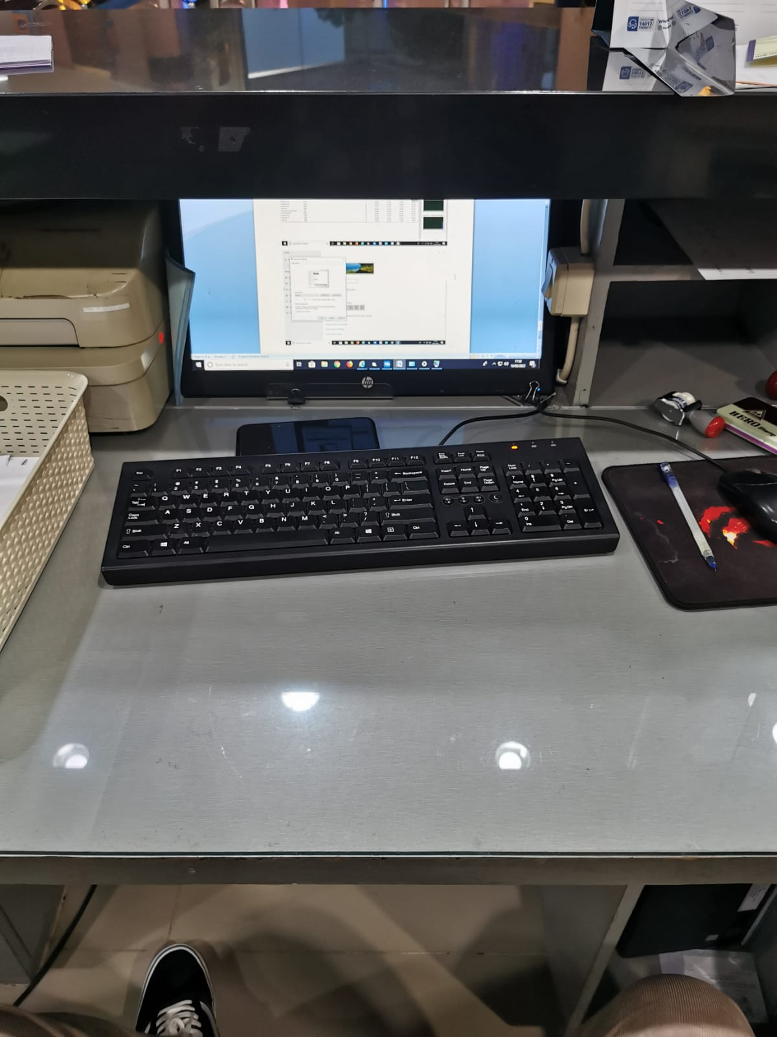

1. **Foto Stiker Pengadaan dan BRIBOX**

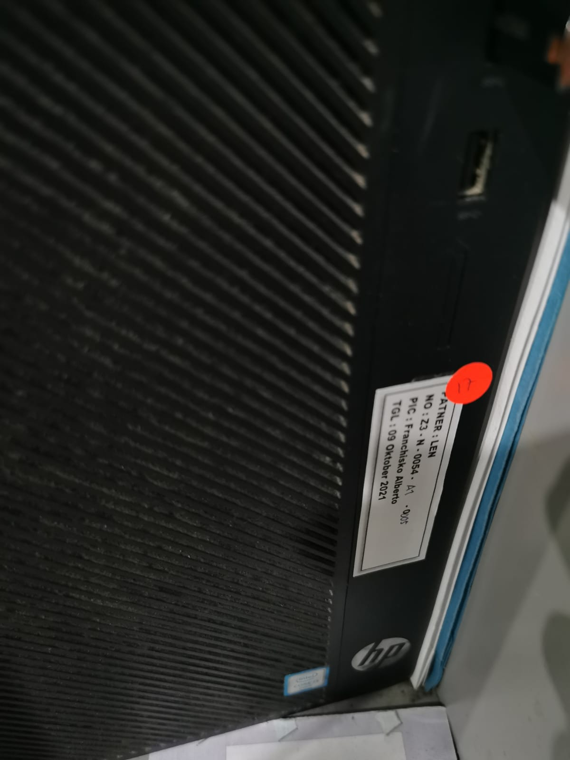

1. **DX Diag (DirectX Diagnostic Tool)**

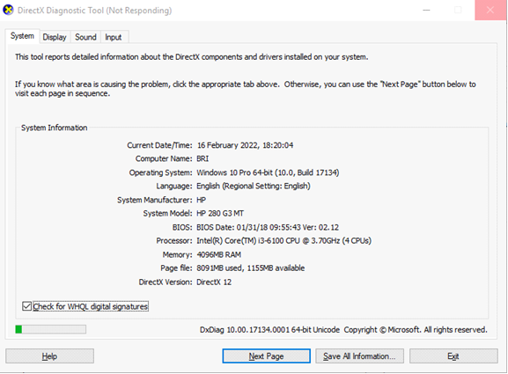

1. **Task manager**

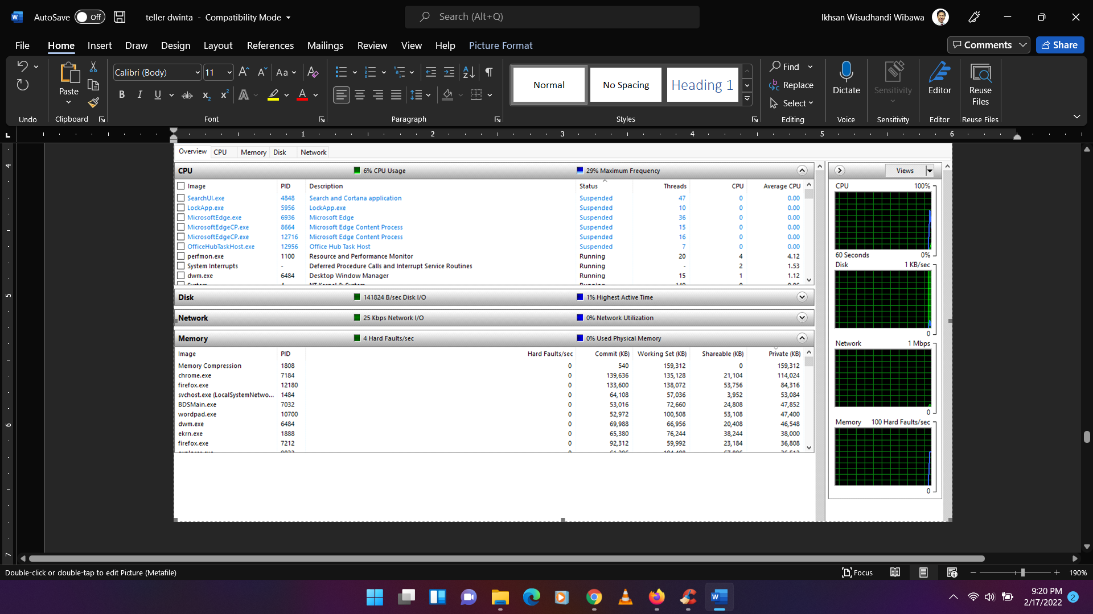

1. **Kapasitas Storage**

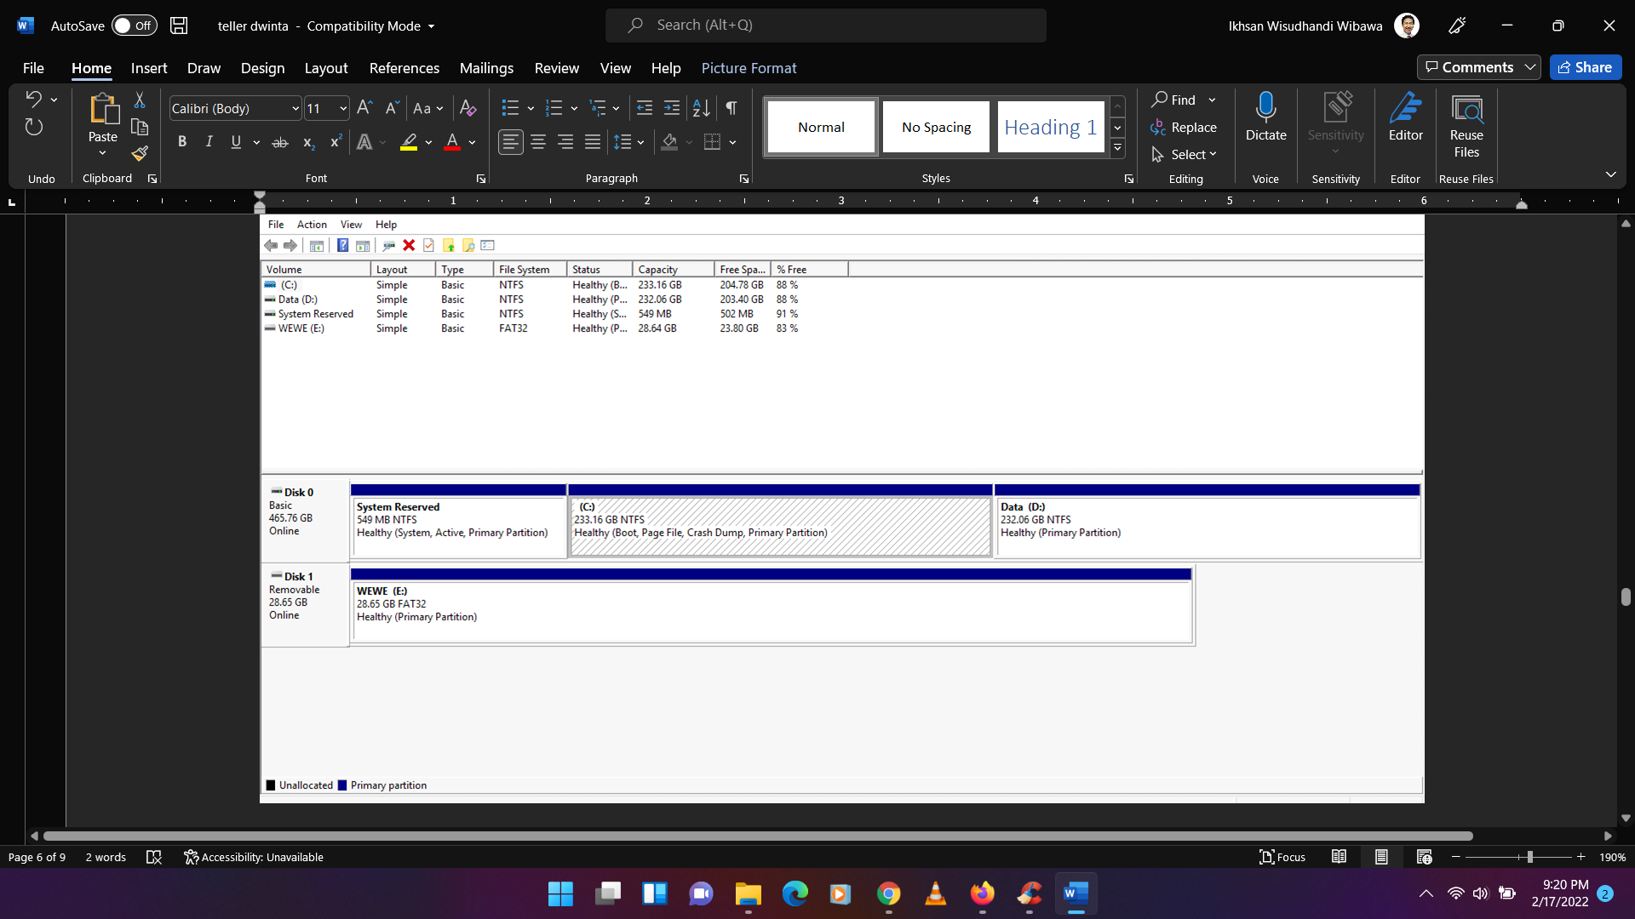

1. **Pengamanan Komputer Pekerja**
   1. **Antivirus**

| Nama Antivirus | : | Eset | |
| --- | --- | --- | --- |
| Version Number | : | 8.0.2039.0 | |
| Last Update (DD/MM/YY) | : | 16/02/2022 | |
| Last Scan (DD/MM/YY) | : | 16/02/2022 | |
| Automatic Update Active | : | ✓ | Ya |
|  | Tidak |
| Scanning secara berkala | : | ✓ | Ya |
|  | Tidak |

**Screen Capture**

1. **About Antivirus**

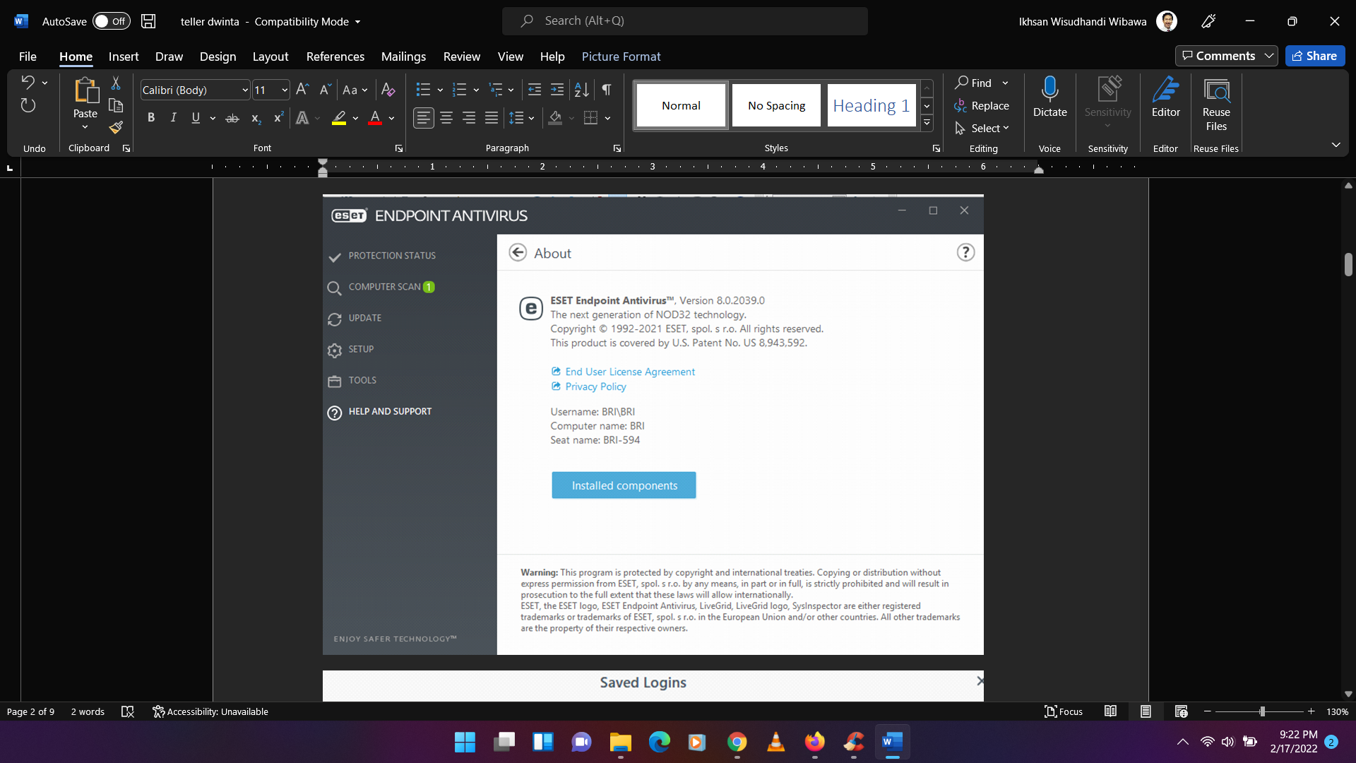

1. **Setting Automatic Update**

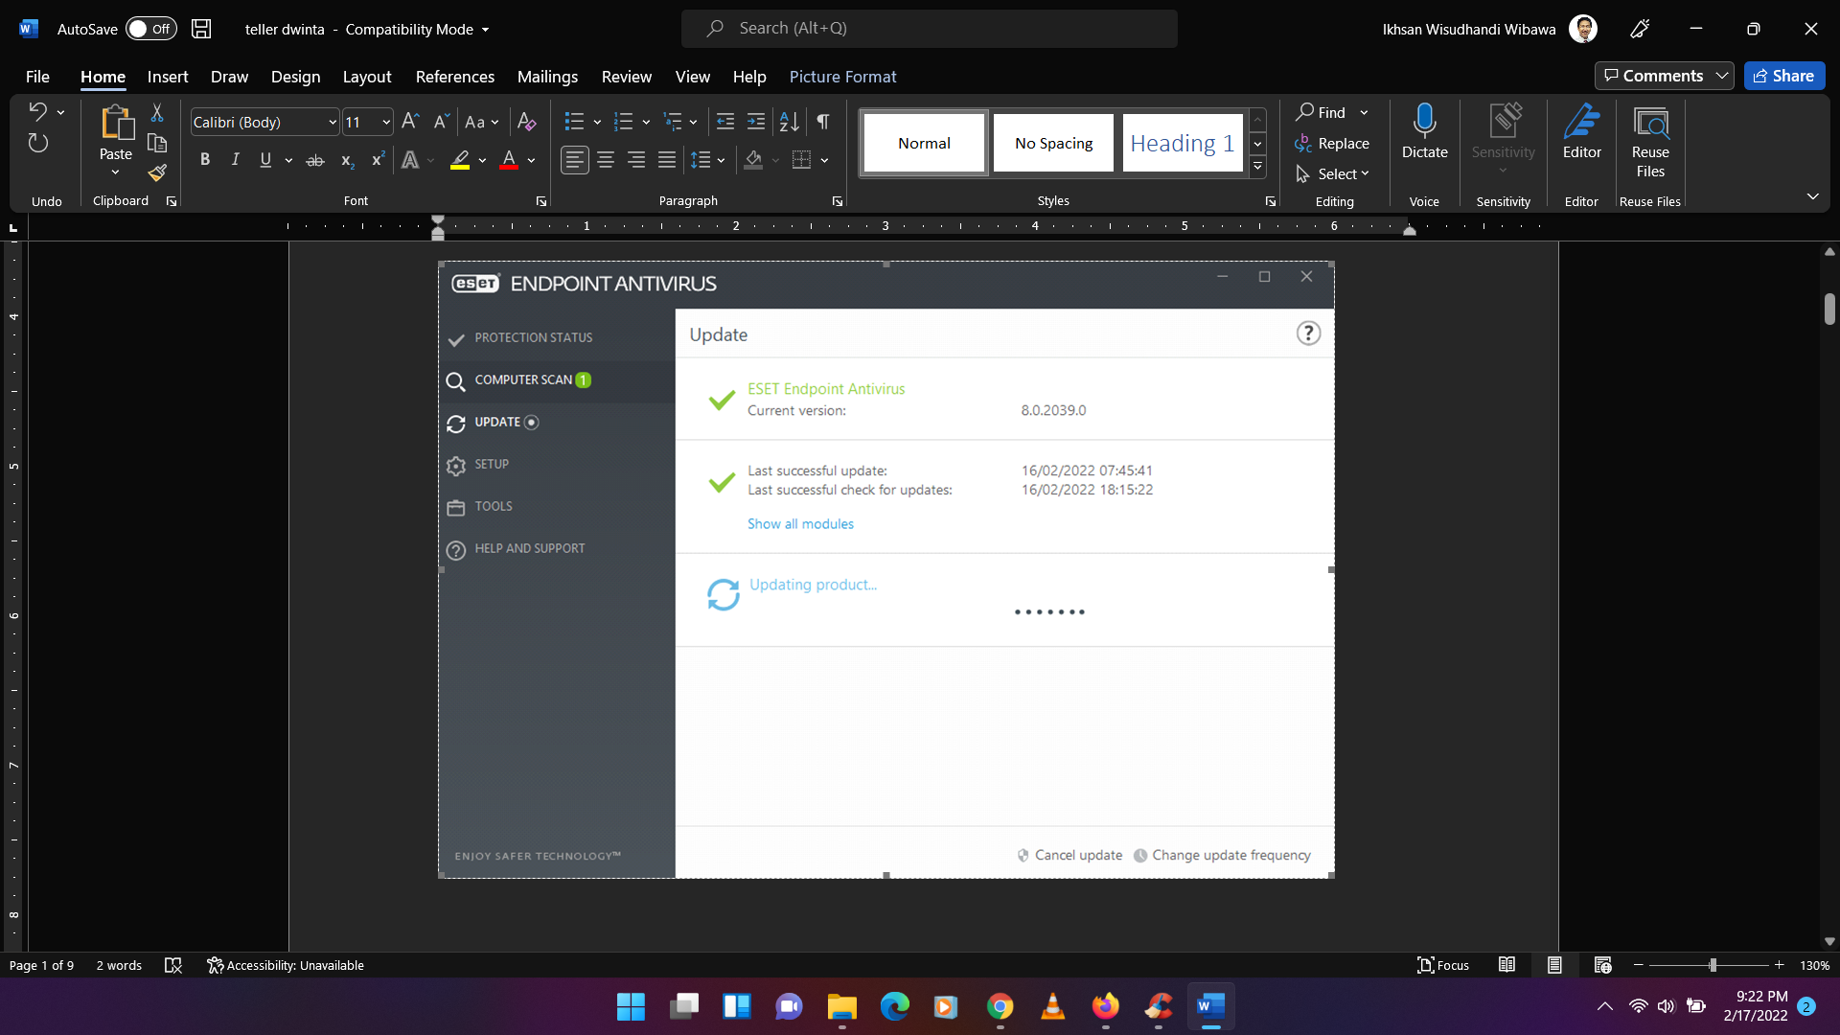

* 1. **Terdapat Fitur Remote Desktop**

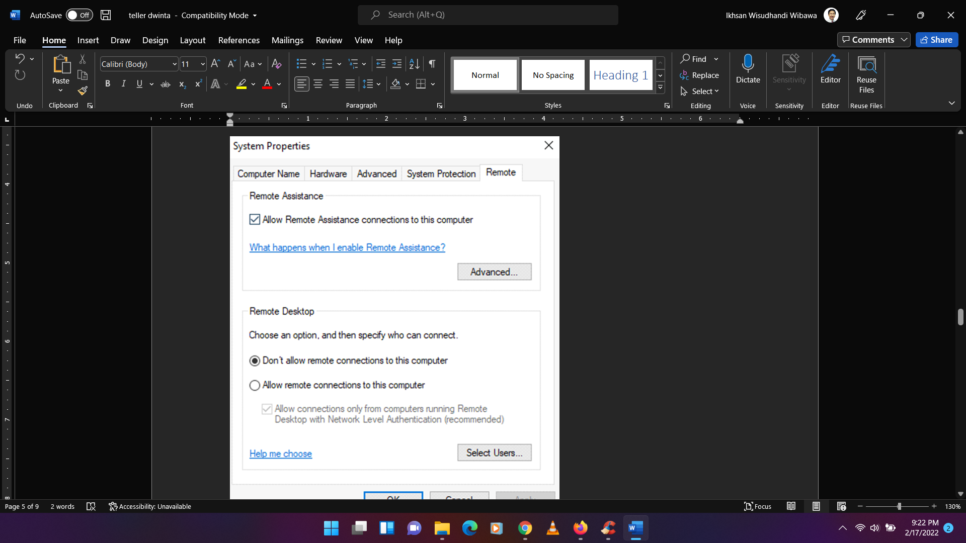

* 1. **Terdapat Fitur Save Password di Browser**

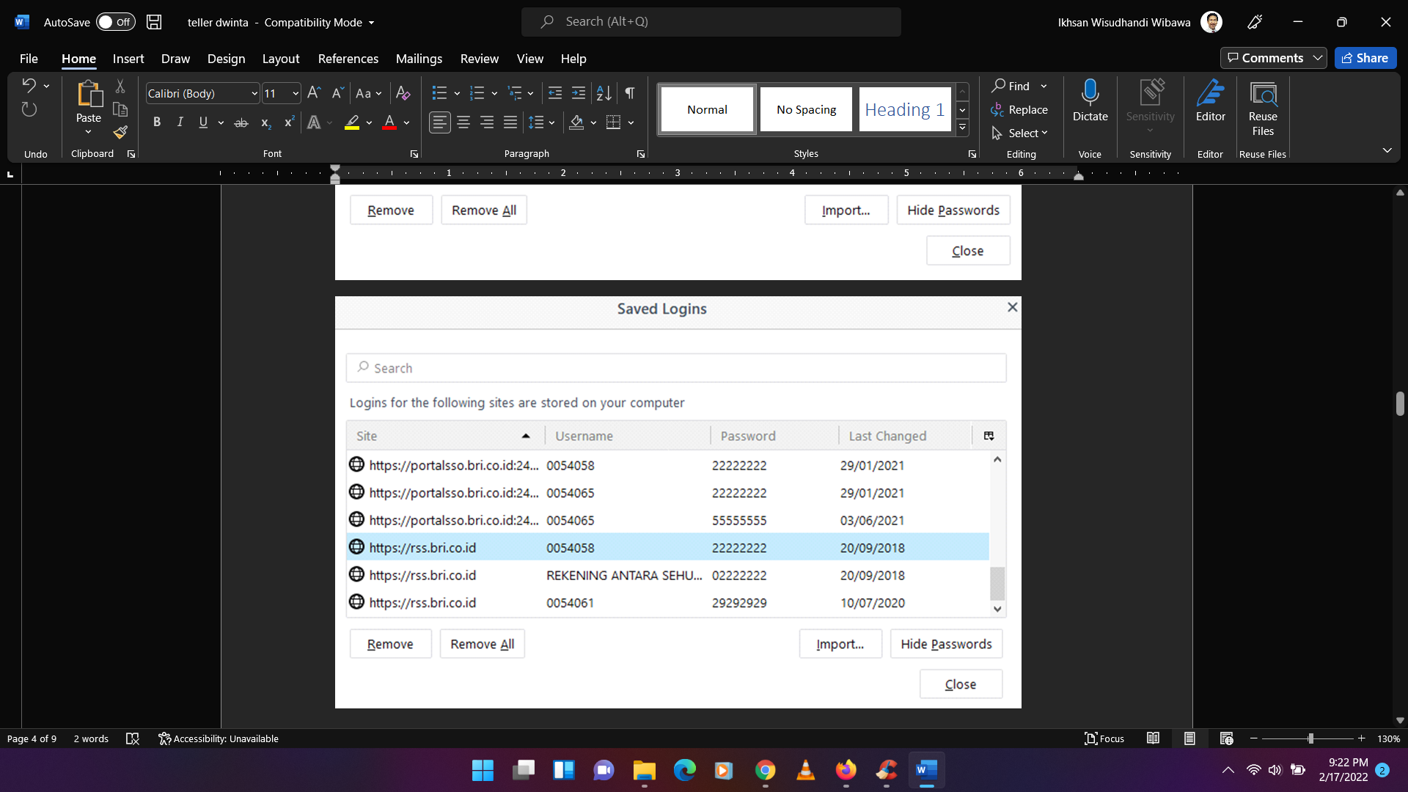

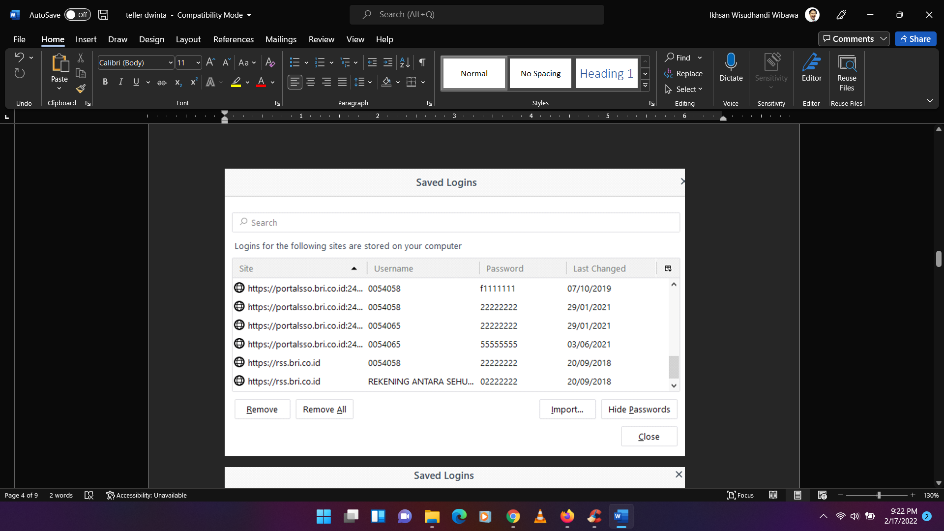

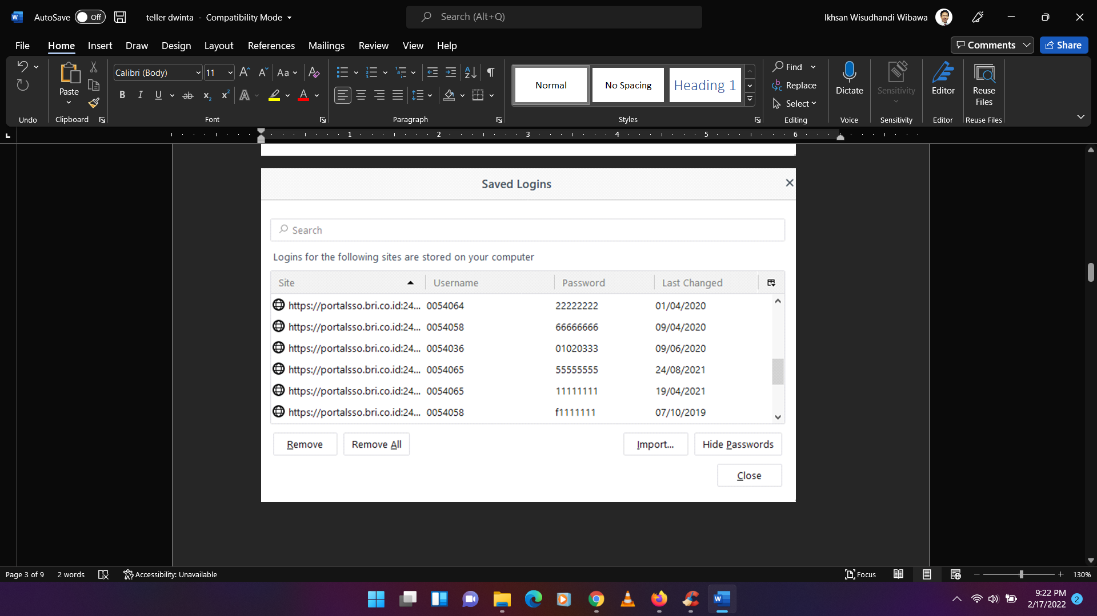

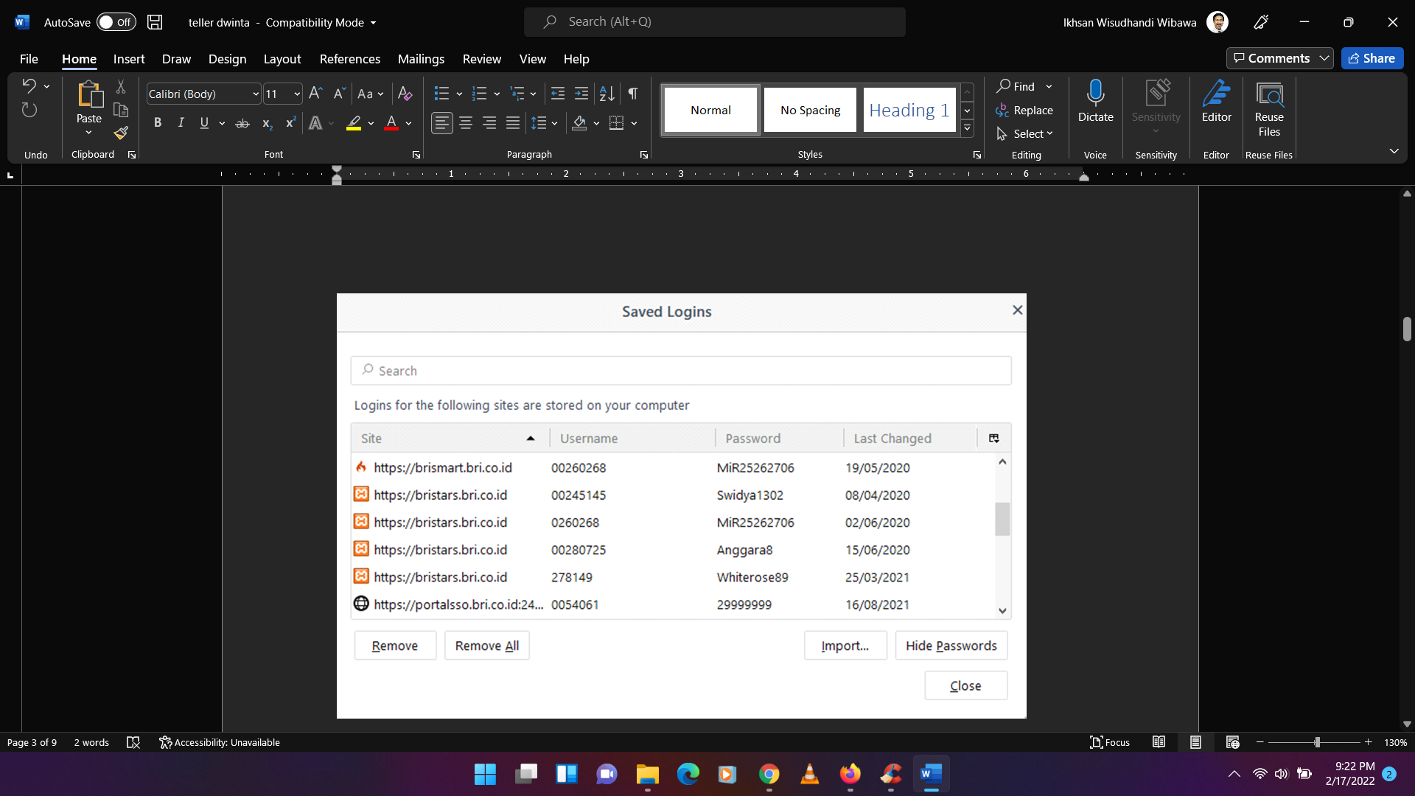

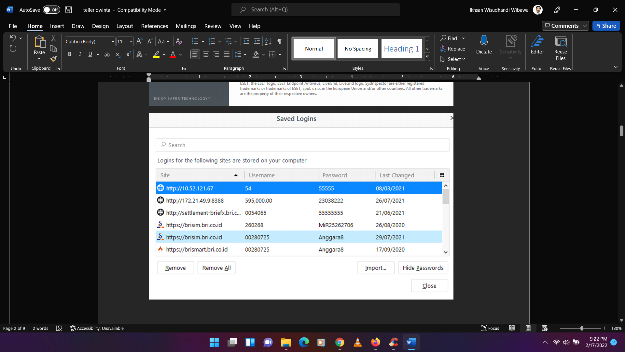

* 1. **Hardening**

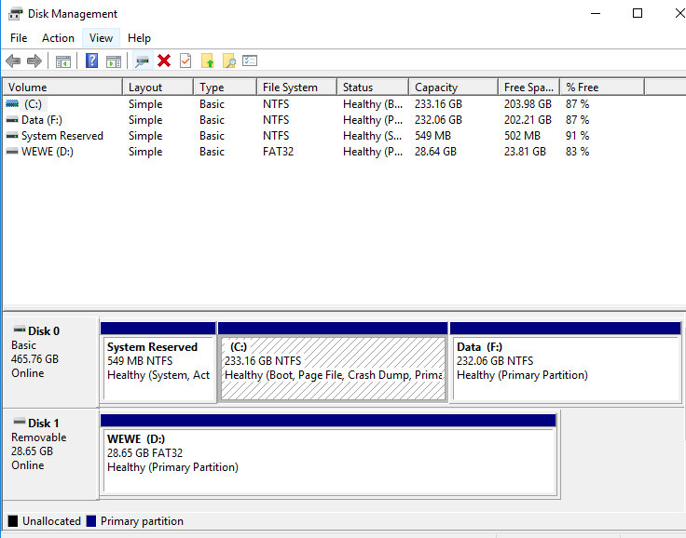

* 1. **Network Time Protocol**

|  |
| --- |

* 1. **Security Awareness**
     1. **Password Masih Standar**

**BRI**

* + 1. **Username Password ditempel di Meja Kerja (-)**